

Diploma in Aerospace System & Management

Final Year Project (EGK324) Report

Project Title:
Development of an electronic device for kitchen fire prevention (Phase 4) & Development of an innovative massage bed

Project Supervisor:
Seah Leng Wah
Project Student:
Tan Jia Hao (211496M)
Abstract
In the recent years, there is a great increase of amount of fire calls in Singapore with most of the fire calls come from residential districts. This report shows the various analytics on the most common sources of fire outbreaks with the official data from 2023, provided by the Singapore Civil Defence Force (SCDF), citing that in residential districts, the most common sources of fire in residential districts is from unattended cooking and charging. We use this data to create a device that tackles the most common sources of fire and reduce the number of fire calls in residential districts in Singapore.
Acknowledgement
I would like to thank Mr Seah, Issac, Daniel. They have generously been guiding me through the process and aiding me throughout various aspects of the project. Mr Seah was able to provide me with valuable feedback, ideas, and resources which was able to help me work further into the project. Issac and Daniel were able to be remain welcome-friendly and contactable whenever I had questions about the project and assist to guide me with valuable information through their experience in the project. Without the help from them, my project wouldn’t have been going so smoothly.
Content
Abstract 2
Acknowledgement 2
1.0 Introduction 5
1.1 Objective 5
1.2 Background 5
Unattended Cooking 6
Electrical 7
PMDs & PMAS 7
1.3 Problem Statement 8
1.4 Scope 8
1.5 Overview 9
Goal 9
Objectives 9
Tasks completed (Fire alarm prevention device) 9
2.0 Project Description [The Smart Alarm] 9
Summary 9
Features 10
Scenario : Electrical failure 10
3.0 Project Requirements 11
Capability of detecting fire and sources of combustion 11
Alert the users when it detects abnormal gas, temperature levels or a fire outbreak. 11
Small and compact design. 11
4.0 Project Development 11
4.1 System Design 12
Schematic Diagram 12
Fire Beetle ESP32 IoT Microcontroller 12
Buzzer 13
Grove Fire Sensor 1 13
Grove Fire Sensor 2 14
Non-Contact Infrared Temperature Sensor – GY-906 MLX90614 14
Gravity: Analog Gas Sensor (MQ2) 15
3D Design 15
Blynk IOT 16
4.2 Software Development 18
Arduino IDE 18
Blynk IOT 21
4.1 Hardware Development 24
Autodesk Fusion 360 24
Ultimaker Cura 27
NYP I&E 30
5.0 System Testing 32
Code & Codes Explaination 33
Abstract 37
The idea of this project to provide a cheaper alternative to a massage sleeve that can be attached to a chair/bed/mattress, controlled using a mobile phone, an innovative massage bed. Catering to a wide variety of people who do not have the same amount of budget to spend on a massage sleeve and have a good quality idea at that. 37
Acknowledgement 37
1.0 Introduction 38
1.1 Objective 38
1.2 Background 38
1.3 Problem Statement 38
1.4 Scope 39
1.5 Overview 39
2.0 Project Description 40
3.0 Project Requirements 41
4.0 Project Development 42
4.1 System Design 42
4.2 Software Development 42
Arduino IDE 42
Blynk IOT 46
5.0 System Testing 49
6.0 Conclusion 49
References 50
Codes 50

1.0 Introduction

1.1 Objective
The objective of this project is to create a device for residential home. Mainly used in the kitchen, that aids in the prevention of a kitchen fire. This electronic device should be able to tackle the leading causes of fire outbreaks in homes and help the prevention of the outbreak, by warning the homeowners before the fire escalates. Example includes overcharging of PMDs.

1.2 Background
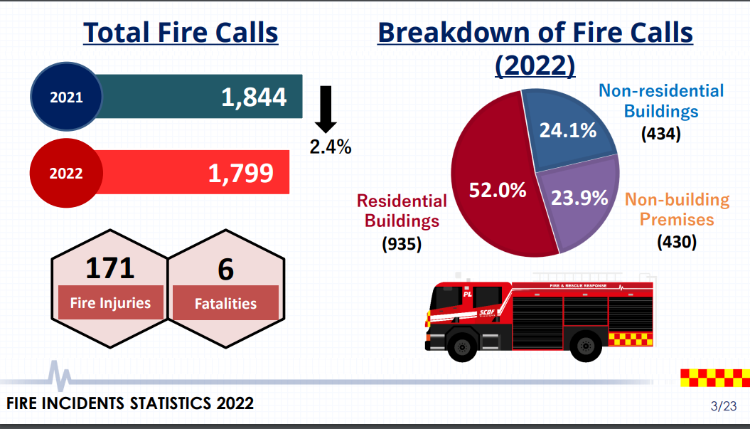
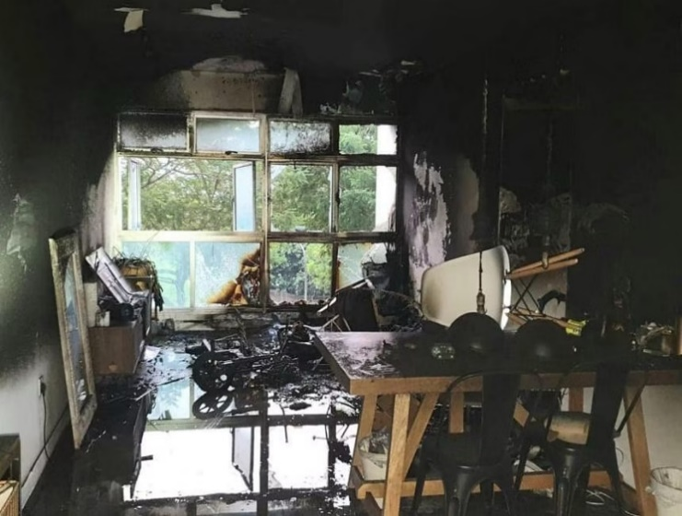
Figure 1 Overview of fire incidents statistics 2022
The number of total fire calls from 2022 is 2.4% lower than the number of total fire calls from 2021, from 1844 to 1799. 1799 is still an extremely large amount, with most of these fire calls coming from residential premises at 953 calls.

Alongside these statistics, one of them was from a fire that occurred in their own home. The unattended charging of the PMDs. Hence, a device that can address these issues in residential premises is prioritized.

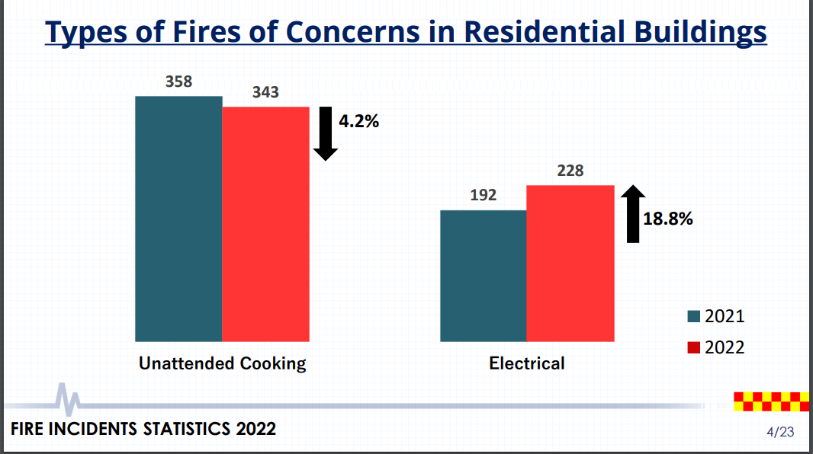

Figure 2 Top three types of fires in residential premises.
With the increasing amount of fire calls coming from residential premises, we must have a solution tackle the leading causes of fire outbreaks in people’s homes. From the statistic provided, the two leading causes of fire outbreaks are from unattended cooking, and that of electrical origin. Another new cause of fire are from PMDs and PABs and they are caused by mainly unattended charging.

Unattended Cooking
In 2022, there was 935 fire incidents that occurred in private/public residential premises. The leading cause on outbreaks, at 343, were from unattended cooking and the overheating of food contents. People constantly forget about their meals that they’ve left cooking on their stove or food that they microwaved causing them to overheat the food and resulting in a fire.

Electrical
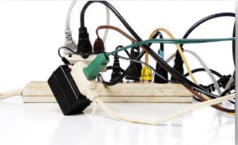
In private/public residential premises, electrical fires ranked as the second-highest cause, totalling 228 incidents, marking an 18.8% increase from 2021 to 2022. These fires typically stem from electrical faults in wiring or appliances, as well as the overloading of electrical sockets. The overloading of electrical sockets occurs when numerous appliances or multiple high-power-consuming devices are simultaneously plugged into a single power socket. This results in the plug overheating in the wall socket due to the heavy load, posing a potential fire risk. Given that a small flame can escalate into a major fire in less than 30 seconds, taking immediate action is crucial to prevent the potential endangerment of lives resulting from a possible outbreak.
Figure 3 Example of an overloaded power point

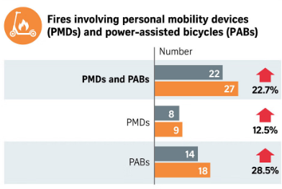
PMDs & PMAS
The Singapore Civil Defence Force (SCDF) reported an increase in fires involving personal mobility devices (PMDs) and power-assisted bicycles (PABs or e-bikes) during the first half of 2023 compared to the corresponding period last year. According to mid-year statistics released on Tuesday (Aug 22), SCDF noted a 22.7% rise in such fires, totalling 27 incidents in the first half of the year, up from 22 in the first half of 2022.Eighteen of these cases pertained to PABs, reflecting a 28.5% increase from the 14 cases in the first half of 2022. Additionally, nine cases involved PMDs, marking a 12.5% rise from eight in the same period the previous years advised users against leaving batteries or devices unattended while charging for an extended period or overnight. It also recommended avoiding immediate charging after use and cautioned against tampering, modifying, or attempting to repair devices.

1.3 Problem Statement
In an ideal situation, residential fire incidents could be significantly reduced if individuals were vigilant in monitoring their cooking and cautious about handling and not overloading their wall sockets with appliances. Unfortunately, circumstances may arise where people forget to supervise their stove or other kitchen appliances, and there are instances where individuals may not realize when their wall sockets are becoming overloaded, leading to the occurrence of fire outbreaks. These incidents often result from negligence and inattentiveness, making it challenging for individuals to promptly notice and address the emerging issues, thereby allowing the outbreak to evolve into a major fire.
To address these challenges, my goal is to prevent such incidents by introducing a device that serves as an alternative for users to monitor their devices, kitchen gas, and temperature levels, while also detecting flames. This device aims to notify users of abnormally high temperatures, gas levels, or the presence of a fire. It is designed for use both inside the kitchen, addressing unattended cooking concerns, and outside the kitchen, where electrical appliance overload may occur. The prompt notifications provided by the device enable users to take immediate action, preventing the escalation of fires. There is also a buzzer that notifies the nearby people when the device detects any abnormality.

1.4 Scope
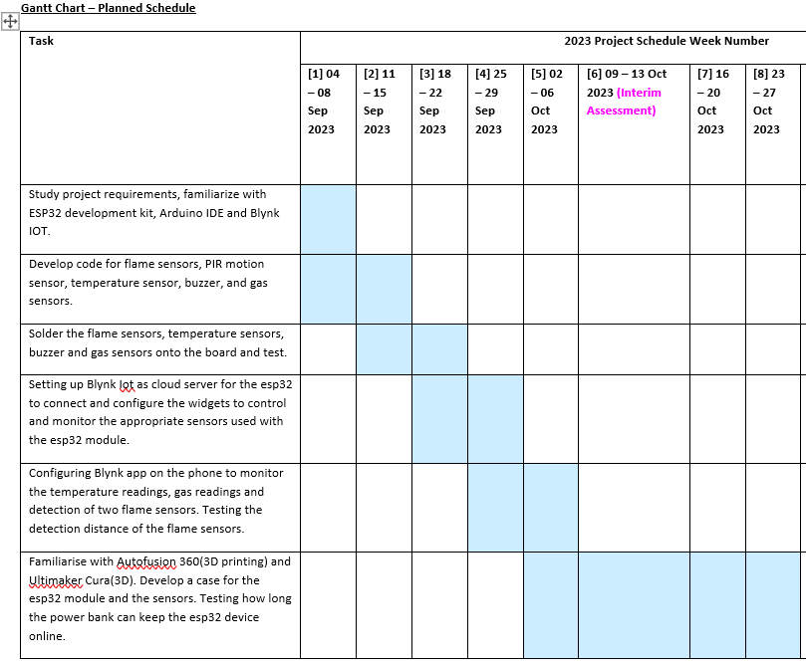

1.5 Overview

Goal
Creation of an electronic device to tackle the fire outbreaks caused by unattended cooking and those of electrical origin. This device is to be used in homes, near the kitchen stove, or close to electrical appliances or the sockets. Hence, we need a system to monitor the surrounding gas levels and temperature levels and detection of flames.

Objectives
- Develop a device that can monitor temperature and gas.
- Develop a device that can detect flames.
- Alert people nearby and the user that there is fire detected.
- Reduce undetected fire cases.
- Provide people an alternative to monitor their devices that are charging.

Tasks completed (Fire alarm prevention device)
- Blynk IOT
- Monitoring systems through the app
- Soldering and wiring of the sensors to the PCB
- Develop and upload code into ESP32 module.
- Setting up a cloud server on Blynk for the ESP32 module to connect
- 3D casing for the device

2.0 Project Description [The Smart Alarm]

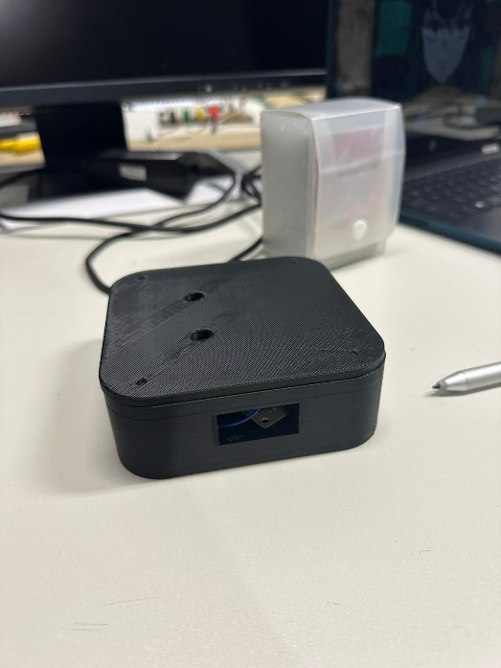
Summary
The Smart Alarm is a small and compact device that you can stick near your kitchen stove or your desk to detect the presence of unattended cooking or a fire outbreak. You can connect it by plugging it on a power socket or by connecting it to a portable charger.
The Smart Alarm uses an ESP32 microcontroller to perform the code, using its built-in Wi-Fi module to connect to the internet and communicate with the user’s phone.
The full list of inputs and outputs used in the device:
- Grove Buzzer
  - Provide a sound indication of warning on the device itself.
- Grove Gas Sensor
  - For measurement of gas levels, to check if there is any abnormally high gas level present in the kitchen while the stove is turned on.
- Grove Fire Sensor
  - To detect the presence of orange flame.
- Non-Contact Infrared Temperature Sensor – GY-906 MLX90614
  - To measure the temperature of the object in front of it or the ambient temperature.
The application used to communicate with the user’s phone is Blynk IOT. The user can monitor the various aspects of the kitchen device through the application like the current temperature or gas level as an example. Blynk is also capable of sending data from the application to the device itself, allowing for data to be sent back and forth.

Features
The primary function of the Smart Alarm is to identify the existence of flames, abnormal gas levels, and temperature fluctuations, subsequently alerting individuals through their mobile phones about these irregularities. Additionally, the device is compact and portable, allowing users to carry it or discreetly place it within their homes without disrupting the environment. Another notable feature addresses is that the device is able to alert surrounding people with the buzzer built in the device. This will then decrease the likelihood of fire outbreak and the amount of fire calls.

Scenario : Electrical failure
In the event of an electrical failure, resulting from either wiring faults or an overloaded power socket, the device will examine for signs of fire, unusually high temperatures, or abnormal gas levels. Upon detecting any of these indicators, it will infer the presence of a fire and promptly notify the user. This ensures that the user receives timely alerts about a potential fire outbreak originating from the power socket or device, even if the device is unable to visually detect flames. The sequence of actions in this scenario is outlined as follows:
- It regularly checks for fire present.
- If no fire is present, the device checks for abnormally high temperatures or gas level.
- If neither sensor returns positive, it will assume that no fire is present in the vicinity.
- If just one of the sensors returns positive, it will send an alarm to the user for a fire.
- The process repeats.

3.0 Project Requirements
- Notify the users and surrounding people when it detects undetected cooking or a fire outbreak.
- Small and compact design.
- Be able to differentiate a fire outbreak from a cooking flame.
- Accurate detection of flame

Capability of detecting fire and sources of combustion
As the intended use of this device is both to detect both a potential fire outbreak and to monitor the gas and temperature levels, The device needs to be able to differentiate between a regular cooking flame and a fire outbreak.

Alert the users when it detects abnormal gas, temperature levels or a fire outbreak.
To ensure that the user can immediately be aware of undetected cooking or a fire outbreak, a notification need to be sent to the phone. A buzzer should sound as well when it detects fire outbreak or abnormal gas or temperature levels to alert the surrounding people that there might be a fire outbreak happening around them.

Small and compact design.
Having a bulky design for the device may prove intrusive when placed in the kitchen. There are also occasions where space is not easily available for the user to place the device. Hence, having a small and sleek design is imperative for user convenience. The design of the device should remain flat so that it does not protrude out when placed on the walls of the kitchen.

4.0 Project Development
The full list of applications used for the development of this device:
- Arduino IDE
  - Used to create and upload code into the ESP32 Device.
- Blynk IOT
  - Mobile and web application used to connect and control the ESP32 via the internet.
- Autodesk Fusion 360
  - Program for creation of the 3D models used for 3D printing.
- Ultimaker Cura
  - Turning the files created in Autodesk Fusion 360 compatible for 3D printing.
- NYP I&E
  - Mobile application for booking an appointment for one of the 3D printers in NYP.

4.1 System Design

Schematic Diagram
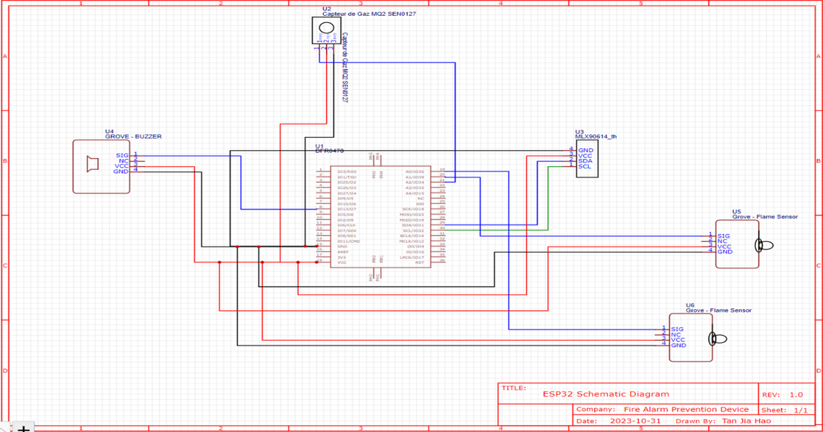
The program starts by detecting the temperature, gas, and flame. The fire sensor can detect orange flames that emit from a fire outbreak, but it is not able to detect the blue flame emitted from the stovetop.
If fire is not detected, but there is abnormal gas and temperature level, and it exceeds the threshold set by the program. It will sound the buzzer and alert the user of the device. It will also alert the surrounding people that something is catching on fire and is currently unattended. Otherwise, if it does not exceed the threshold, the program stops and waits for the next interval.

Fire Beetle ESP32 IoT Microcontroller

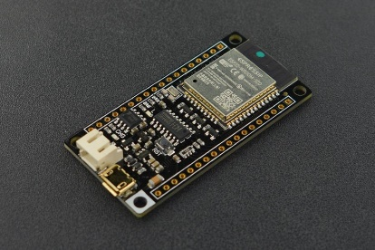
The reason why we chose FireBeetle ESP32 IoT Microcontroller is because it is a compact and powerful development board designed for Internet of Things (IoT) projects. Key features include an ESP32 microcontroller with dual-core processing, built-in Wi-Fi and Bluetooth, a compact form factor suitable for prototyping, a rich set of I/O ports, and USB-to-Serial capabilities for easy programming. The board is well-suited for IoT applications, offering a balance of wireless connectivity and compatibility with sensors and modules. It can be programmed using the Arduino IDE and is popular in the IoT development community.

Buzzer
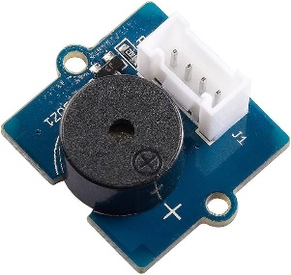
Pin Configuration |  | Specifications
Gnd | Gnd | Operating Voltage : 3.3-5V
VC | VCC | Sound Output : ≥ 85dB
SIG | 13 | Dimensions (mm): 24 (L) x 20 (W) x 9.8 (H) Weight :10g
The Buzzer activates when:
- The Flame is detected.
- Abnormal Gas levels (3000~4095)
- Abnormally high temperatures (30 °~50 °)

Grove Fire Sensor 1
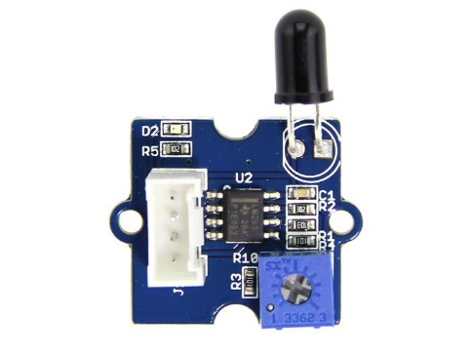
Pin Configuration |  | Specifications
GND | GND | Operating voltage: 5V
VCC | V5 | Operating Temperature: -25℃ ~ 85℃
NC | Not Connected | Detection Range: 0 ~ 1m
D1 | G36 | Dimensions: 130mm x 80mm x 12mm
The Grove Fire Sensor is consistently operational in the program to identify the presence of an orange flame. The specification of a yellow flame, rather than a blue flame, is based on the distinct wavelengths emitted by different types of flames. The wavelength emitted by a yellow flame during a fire outbreak differs from the wavelength emitted by a blue flame when the stove is in use. The Grove Fire Sensor can successfully detect the wavelength emitted by a yellow flame, while the wavelength from a blue flame falls outside the sensor's detection range. To prevent false positives, the sensor conducts a secondary check to confirm the persistence of the yellow flame after a set interval. Only if the yellow flame persists will it conclude that a fire outbreak is occurring. This precautionary measure avoids situations where the stove intermittently emits yellow flames, potentially indicating a fire presence when it is simply in use for cooking.

Grove Fire Sensor 2
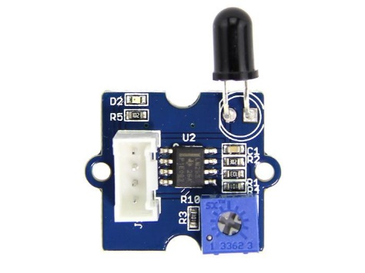
Pin Configuration
GND | GND
VCC | V5
NC | Not Connected
SIG | G39
Effective range of the sensor: 80cm
- This flame sensor can be used to detect fire source or other flame spectrum but mainly orange flame.
- The detection distance of the flame of lighter is 80 cm. The larger the flame intensity, the farther the test distance is.
- Detection Angle: about 60 degrees.
- It is based on the YG1006 sensor which is a high speed and high sensitive NPN silicon phototransistor. Due to its black epoxy, the sensor is sensitive to infrared radiation.

Non-Contact Infrared Temperature Sensor – GY-906 MLX90614
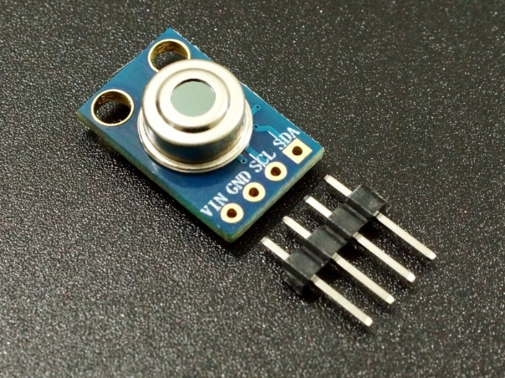
Pin Configuration
VIN | V5
GND | GND
SCL | G22
SDA | G21

- The key feature of the MLX90614 is that it is a high-precision, contactless IR temperature sensor.
- Due to its high accuracy and precision, it is also used in a wide range of commercial, health and household applications such as room temperature monitoring, body temperature measurement, etc.
- It measures the temperature without contact by using the Stefan-Boltzmann Law, which is by measuring temperature through the amount of IR energy emitted by the object or living thing as it is proportional to temperature.

Gravity: Analog Gas Sensor (MQ2)
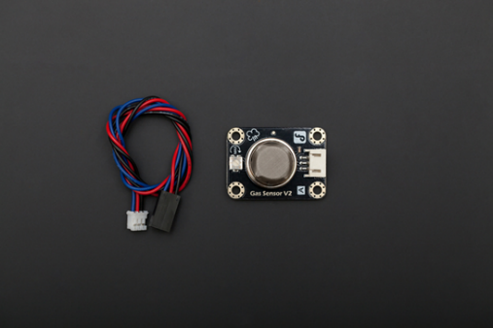
Pin Configuration |  | Specifications
VIN | V5 | Power supply needs: 5V
GND | GND | Interface type: Analog
SIG | G34 | Size:36.4x26.6mm (1.4x1'')

- This is a generic Arduino gas sensor.
- It has MQ2 probe which is able to detect LPG, i-butane, propane, methane ,alcohol, Hydrogen, smoke.
- Normal condition gas sensor output range is 200~1000
- Kitchen cooking condition : 1000~2500
- Burning condition: 3000~4095

3D Design
Device dimensions: 110mmx110mmx35mm
The container for the device has gone through many different iterations. 3D modelling and printing took much longer than anticipated due to the inaccuracies of my measurement and from the 3d printer itself. It is designed to be as small as possible while still able to insert every component inside.
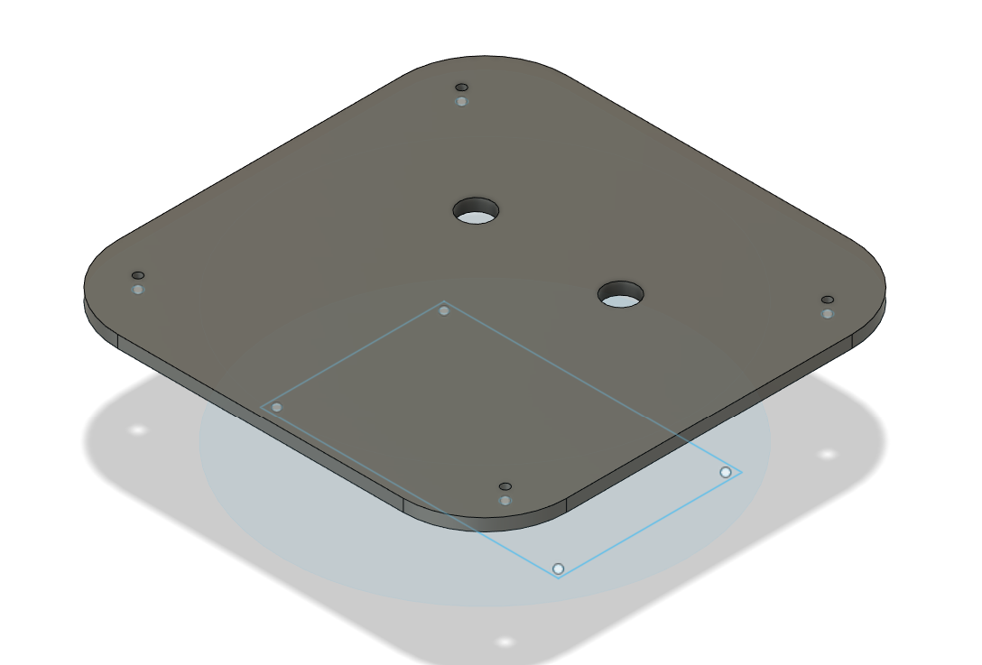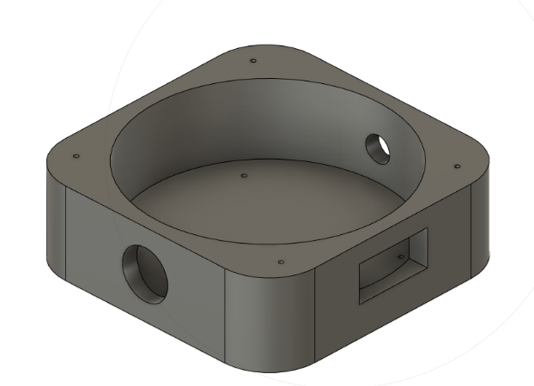

Blynk IOT
The Blynk IOT website and application allows the device to communicate through the internet, sending useful data to and from the application and the device. These are the DataStream used for this project.
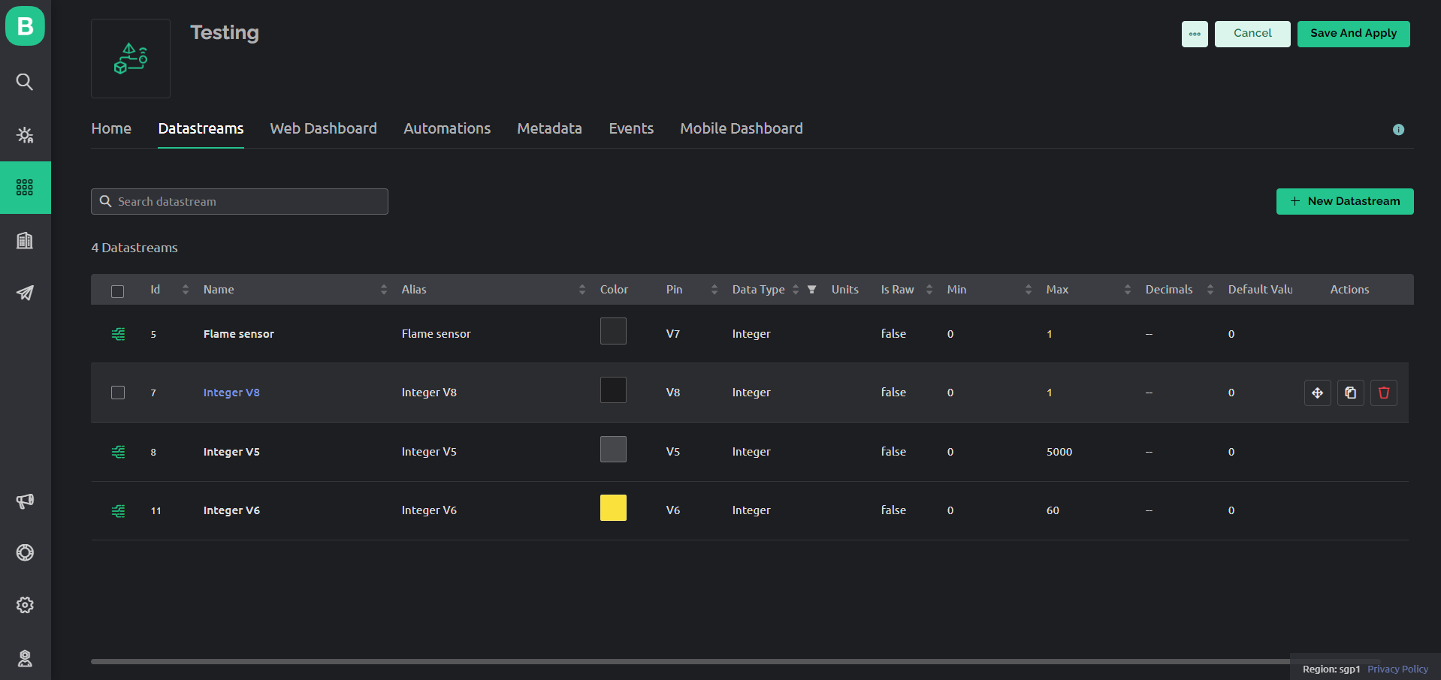
The Web Dashboard can be used to display useful data like the current temperature, gas level, flame detection. The widgets have to have the data streams inserted so that It can display the appropriate data required. The aesthetics of the dashboard can be set according to your preferences.
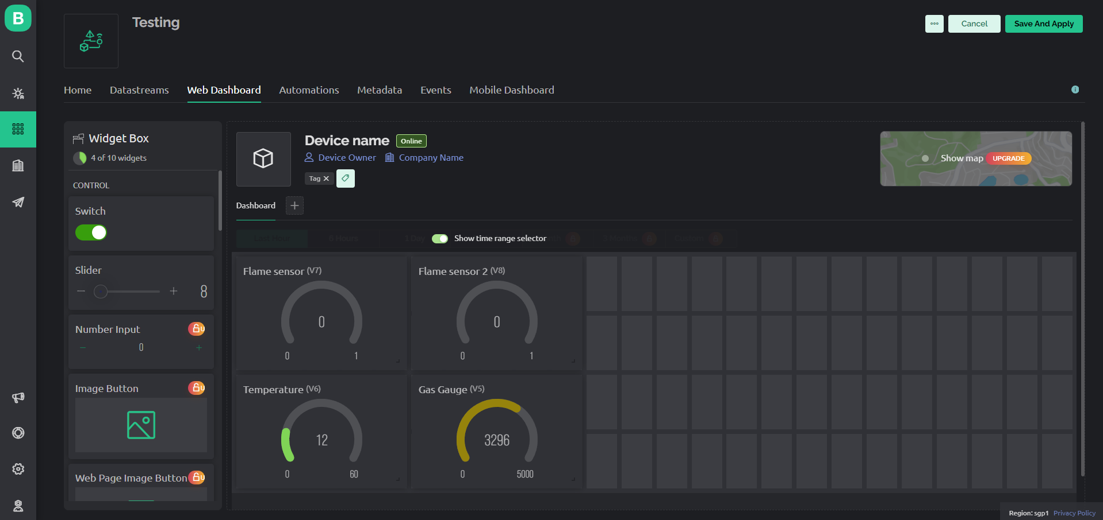

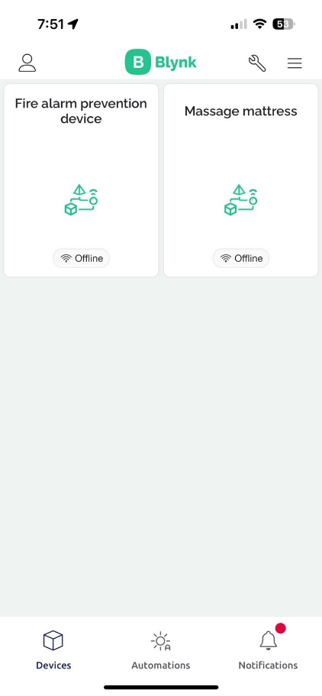
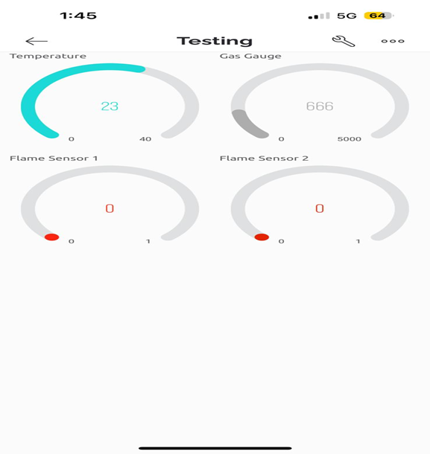
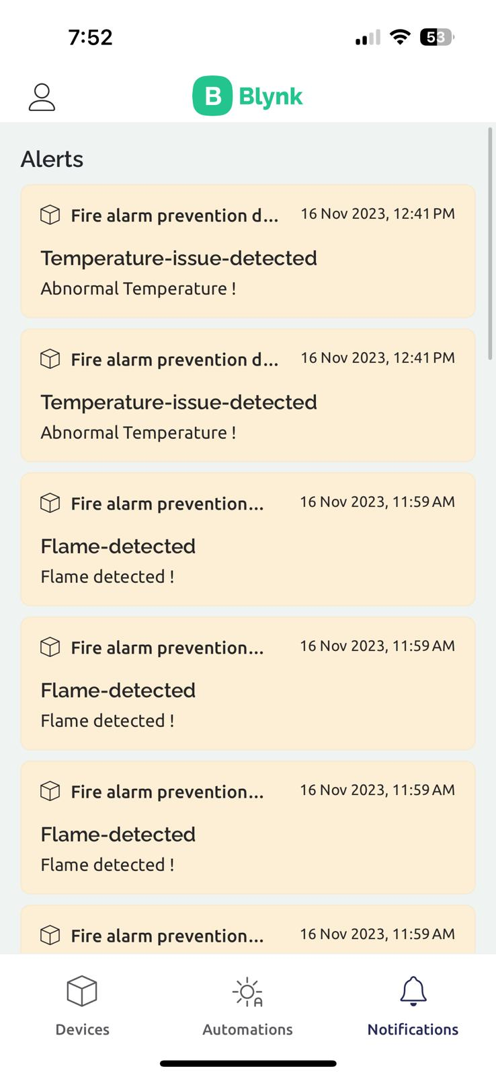
The Mobile Dashboard can also be used to display useful data like the current temperature, gas level, flame detection. DataStream must be inserted into these widgets as well for it to work. The DataStream are set from the website itself. The Blynk IOT application is also used to notify the users through alerting notifications. If a fire outbreak occurs or abnormal gas or temperature level, the phone will receive an alert warning the user

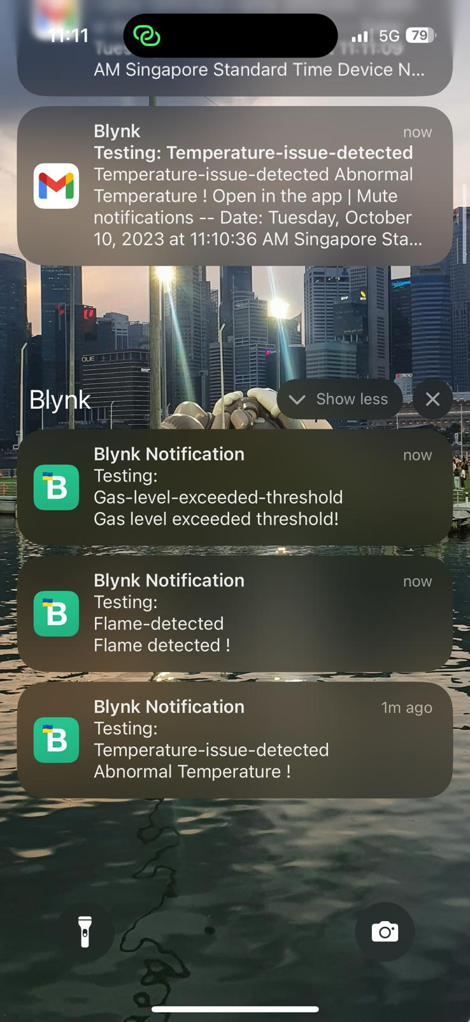
.

4.2 Software Development

Arduino IDE
Arduino IDE is the main program used to create the code for the device in this project. It is compatible for both Arduino UNO and ESP32. However, there are differences in the code used for both, so it is important to research on the code specifically for the device you wish to use.

Download
Download site: https://www.arduino.cc/en/software
On the download page, choose the download option compatible for your PC. For Windows PC with Windows 10 or newer, click the option boxed in red, as shown in the picture below.
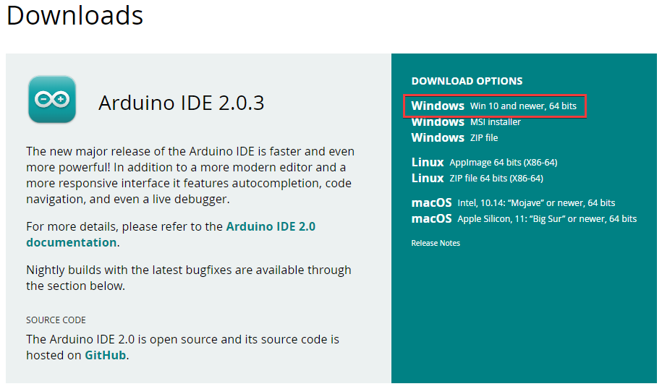
Click on “JUST DOWNLOAD” and proceed to download the installer.
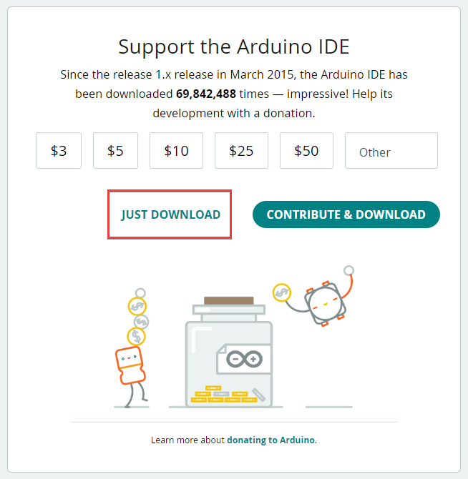
Execute the installer application once finished and follow the steps to acquire the program.

Setting up library
In the program itself, it is required for you to install various libraries to ensure the various aspects of the device can function sufficiently.
The list of libraries installed for this device:
- Adafruit BusIO
- Adafruit MiniMLX90614
- Adafruit MLX90614 Library
- Blynk
To install these libraries, o pen the Tools drop down list and click on “Manage Libraries…” to open the library manager. Alternatively, you can open the library manager by pressing Ctrl+Shift+I.
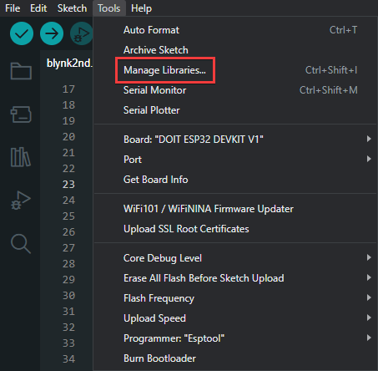
Search for the required library using the search box and press install to retrieve it for your program.
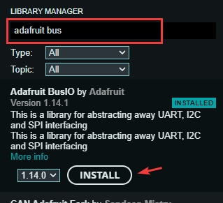

Connecting the device
[Do the 5 steps listed in “Installing ESP32 Add-on in Arduino IDE”]: https://randomnerdtutorials.com/installing-the-esp32-board-in-arduino-ide-windows-instructions/
To connect your device to the software, you can change your port by clicking on the current port and selecting “Select other board and port…”.
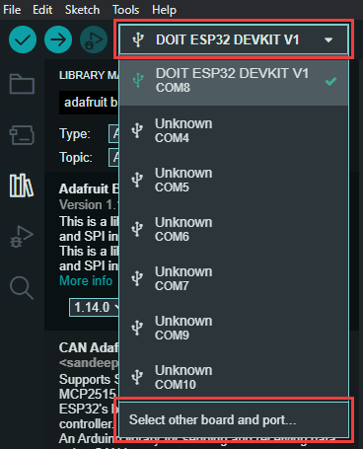
The board used for this device is DOIT ESP32 DEVKIT V1. As for the port, you can check which port is being used when it is being connected by checking through the Device Manager.
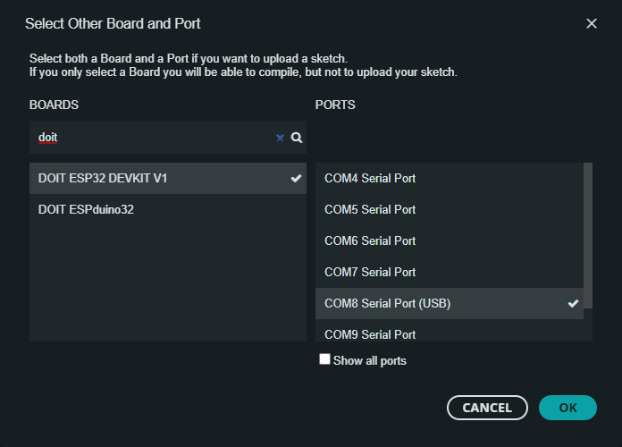
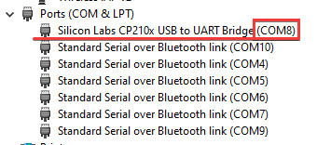

Blynk IOT
Blynk IOT will be used to allow your ESP32 to connect to the internet to send and receive data from your phone or computer. Installation is not required on your computer. However, an account is required to be created on the Blynk site and an application on your phone needs to be installed.

Setup
Site: https://blynk.cloud/dashboard/register
Register an account on the link provided and follow the instructions the site provides. When prompted with the QuickStart option, accept it for an easier setup for your device.
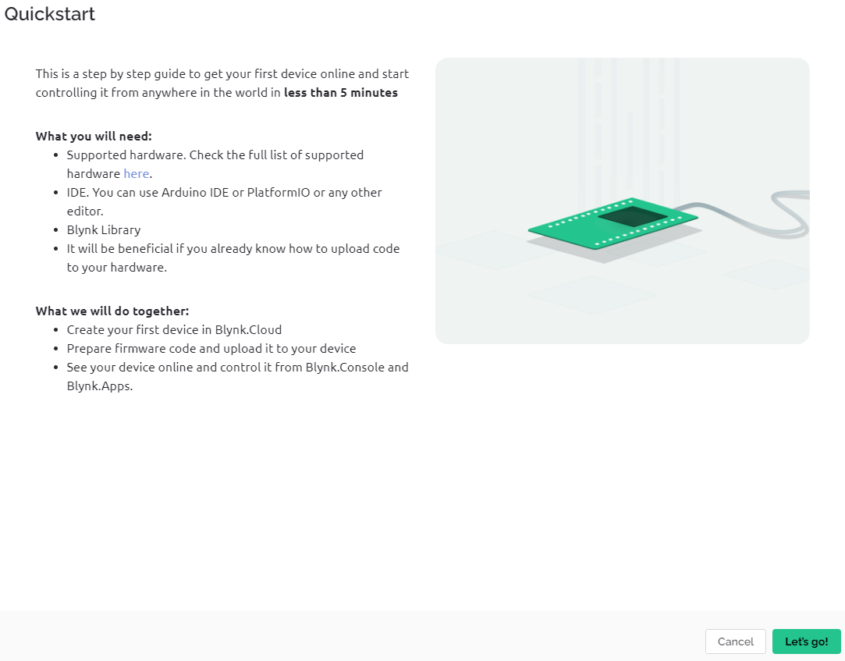
These are what is required for each step:
- Hardware
  - ESP32
  - Wi-Fi
- IDE
  - Arduino
- Blynk Library
  - Library installation in Arduino has been addressed here.
- Code
  - Use your mobile hotspot name and password.
  - Follow the steps listed in the site for 4.
- Device activation
  - Follow the steps listed in the site for 5.

Serial Monitor
If you receive “Wrong boot mode detected (0x13)” Hold down the BOOT button on the ESP32 during upload.
On your Arduino IDE, open the Tools drop down list and click on “Serial Monitor” to open the serial monitor. Alternatively, you can open the Serial Monitor by pressing Ctrl+Shift+M.
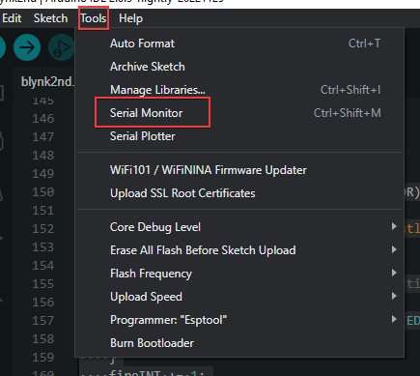
At the right of the serial monitor, ensure that the baud rate is “115200 baud”.
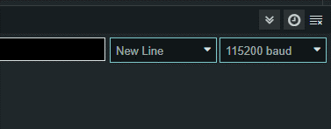
For more instructions, follow this video on how to use the Blynk App: https://youtu.be/DEaDy4ki9E8
Add more virtual pins: https://docs.blynk.io/en/legacy-platform/legacy-articles/what-is-virtual-pins
Adding notifications: https://youtu.be/TeialnF3Mek

Mobile application
Download the Blynk IOT application and log in with the account you have created.
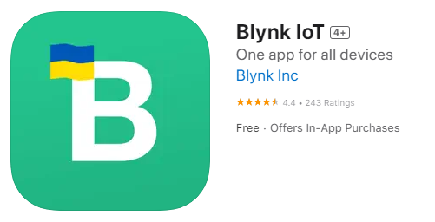

Adding more accounts into the same application
The same account can be used on multiple devices if needed to evaluate on multiple phones. However, if you need another account to be connected to the same Blynk device, these steps are to be followed:
- As the host
  - Navigate through the website as shown in the image below.
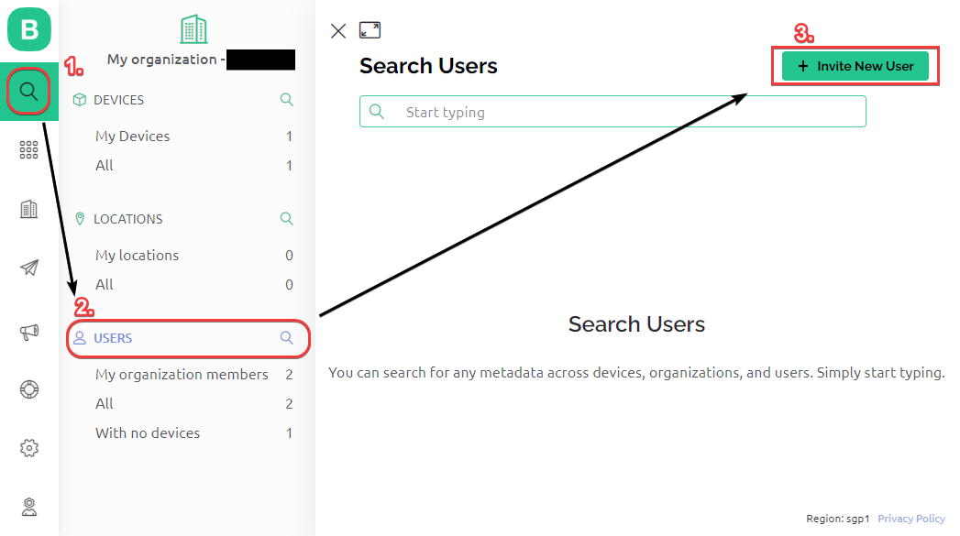
  - Enter the details of the new user.
    - Name
    - Email
    - Role (Set as User)
    - Phone Number
  - Press “Invite”
- As the user
  - Log into your email and find the email from Blynk.
  - Create the password for your account.
  - Install the Blynk IOT application.
  - Log into the application with your account.
You cannot create an account beforehand and invite the account with the host. The account must be created through the email the host sends. Otherwise, the new account will not be able to access the Blynk device.

4.1 Hardware Development

Autodesk Fusion 360
Autodesk Fusion 360 will be used to create the 3D model for the container of the device. Make sure you take proper measurements of the device before proceeding on the creation of the 3D model. The 3D printing process takes a very long time so improper measurements may lead to an hour or more wasted reprinting the container.

Setup
Download site: https://www.autodesk.com.sg/products/fusion-360/
Sign into Autodesk using your NYP email and password. Afterwards, click on the following:
“Support” > “Downloads” > “Students and educators”
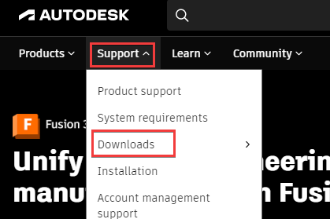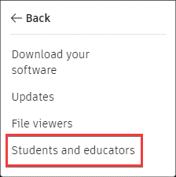
Look for Fusion 360, press “Get started” to proceed to download.
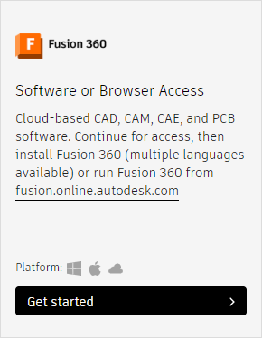
Once the download has finished, launch the .exe file and start the application.

Useful tools
In the process of creating the 3D model, these were the most used tools in the program alongside their default key bind if they had any.
- Create Sketch
- Extrude (E)
  - When extruding with a negative number, it will instead cut the main body from the face selected.
- Box
  - Used to get started on the 3D model. When creating a box attached to the main body, it will automatically join.
- Move/Copy (M)
- Inspect (I)
  - Required to take measurements from one point to another, to ensure accuracy of the model.
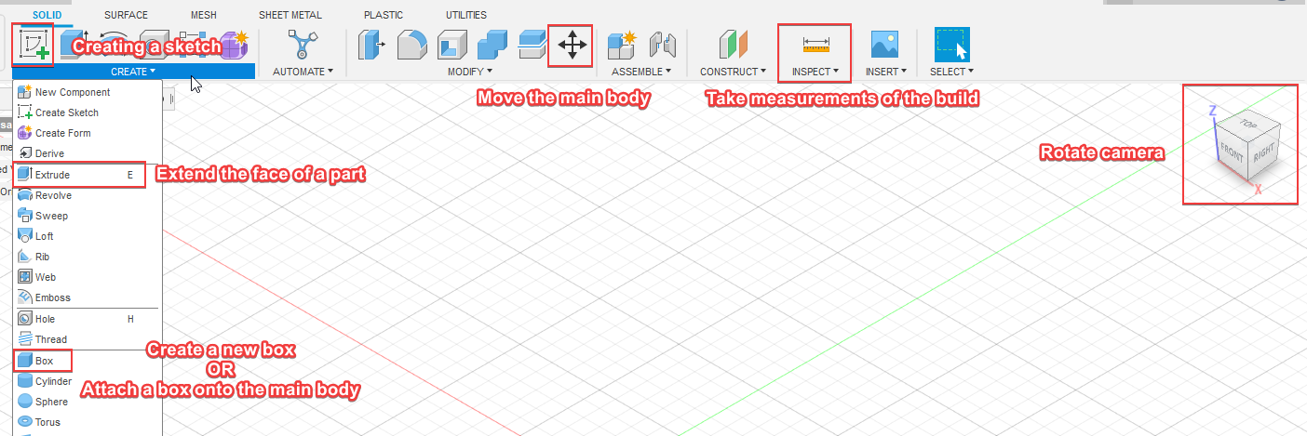
The “Create Sketch” tool is useful to get started on the base of the model. Use “Sketch Dimension” (D) to input and show the lengths of every important measurement.
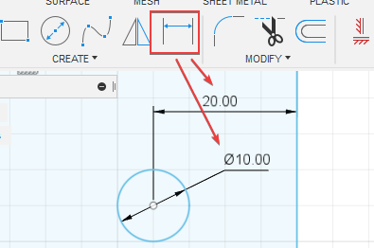
Once you are done with the sketch, use “Extrude” on the sketch to give it depth. Ensure that the thickness of the walls/base/top are not too thin. Greater than 1.6mm is ample thickness to create a sturdy enough wall/base/top for the device.

Exporting
Once you are satisfied with the model, exporting is required to create a compatible file to send into Ultimaker Cura. Ultimaker Cura requires STL files inputted to turn those files into something compatible for the Ultimaker 3D printers.
Open “File”, locate “Export” in the list and click on it.
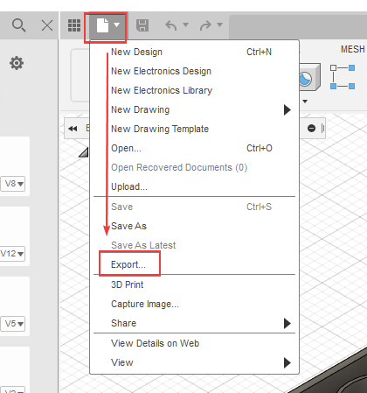
Name your file, ensure that the type of file selected is “STL Files (*.stl)”, take note the location of the export and click “Export”. The exporting process takes a while to complete.
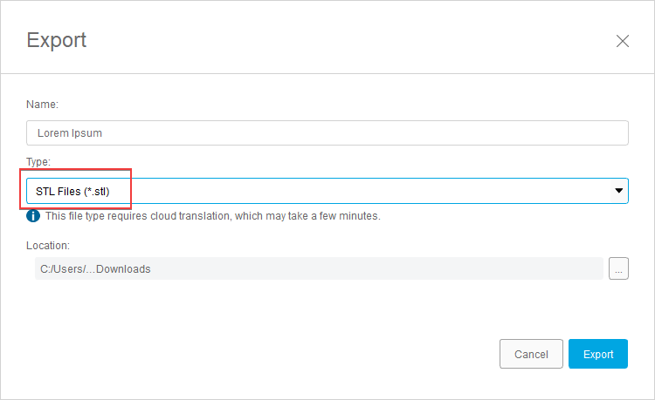
Extra resources:
- Fusion 360 Tutorial for Absolute Beginners (2020)
- Day 1 of Learn Fusion 360 in 30 Days for Complete Beginners! - 2023 EDITION

Ultimaker Cura
Ultimaker Cura is used to turn the STL file exported from Fusion 360 into a file suitable for 3D printing in one of the 3D printers in NYP’s Makerspace. You need an SD card to insert into the 3D printer for printing. You are able to borrow a SD card as well as an USB-to-SD adaptor from the desk at Makerspace itself.

Setup
Download site: https://ultimaker.com/software/ultimaker-cura
Press “Download for free” and select the operating system of your PC/Laptop to start downloading.
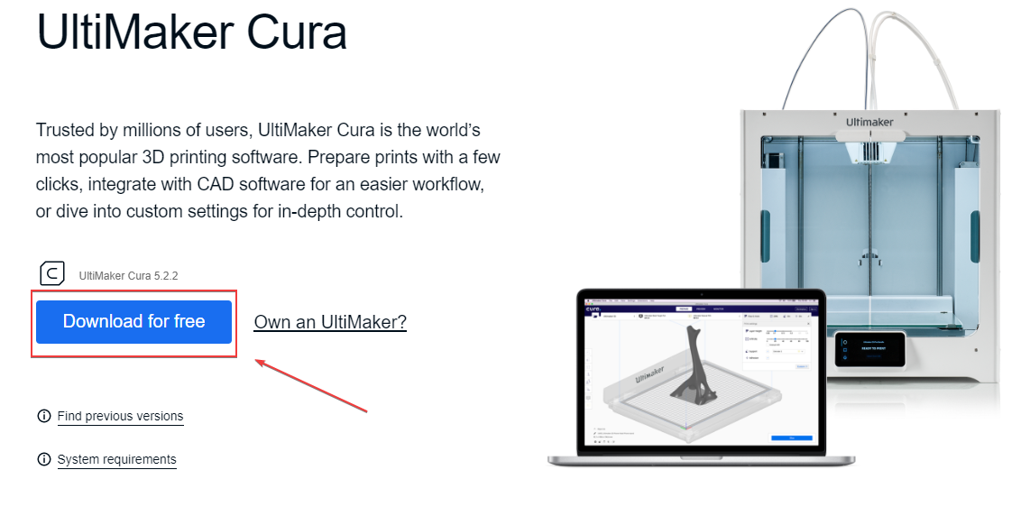
Once the download has finished, execute the application, and follow the setup instructions. In the application itself, ensure that the settings for the material and nozzle is PLA and 0.4mm respectively.
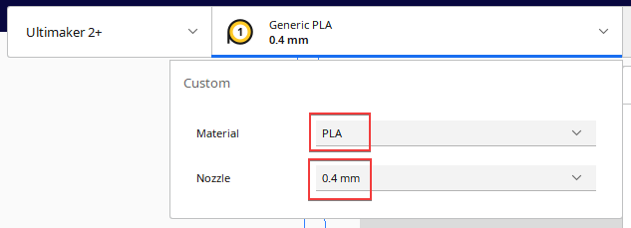

The printer selected should be “Ultimaker 2+” as most of the 3D printers in makerspace are of that model. If the selected printer is incorrect, press the arrow beside the printer’s name, press “Add Printer” and add a non-networked printer with “Ultimaker 2+”.
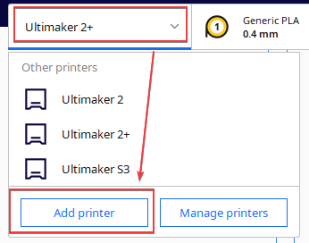
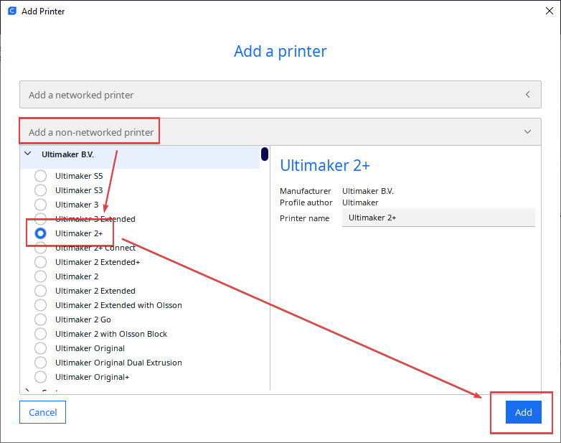


Preparing the print
To import the STL file from Fusion 360, select on “File” at the top left of the application, and click on “Open File(s)…” (Ctrl+O). Select the file you wish to import, and it will appear on the board itself. You can change the position of the print by selecting it and dragging on the arrow keys that appear. The icons shown on the right allow you to change the position, adjust the scale and rotate the print respectively
When preparing the final product, these are the settings that I use:
- Resolution: Normal – 0.15mm
- Infil: 20%
- Support: ✔
- Adhesion: ✔
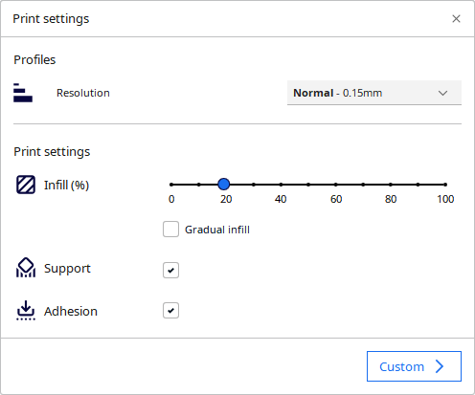
You can change the settings as much as you like. However, these are the settings that I found to have the quickest printing time while keeping the structural integrity of the print. Afterwards, click on “Slice” at the bottom right and then “Save to Disk” or “Save to Removable Drive” at the same location. You have now prepared a file ready for 3D printing.
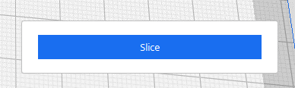
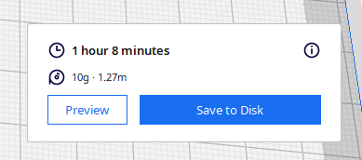

NYP I&E
The NYP I&E application is used to book a 3D printer at Makerspace. The process of 3D printing usually takes 30 minutes to 2 hours depending on the size of the print. The location of Makerspace is behind the South Canteen.
There are things to note when it comes to using the 3D printer:
- A maximum of only 2 hours of print is given to you. You can request for a longer time from the coaches.
- It is a rule that you must stay near your 3D printer while it is printing. Regularly check on the print to ensure that there are no errors during the printing process.
- An SD card is required for 3D printing. You can ask the coaches to borrow one for temporary use.
- The SD card must stay inside the 3D printing while it is printing.

Setup
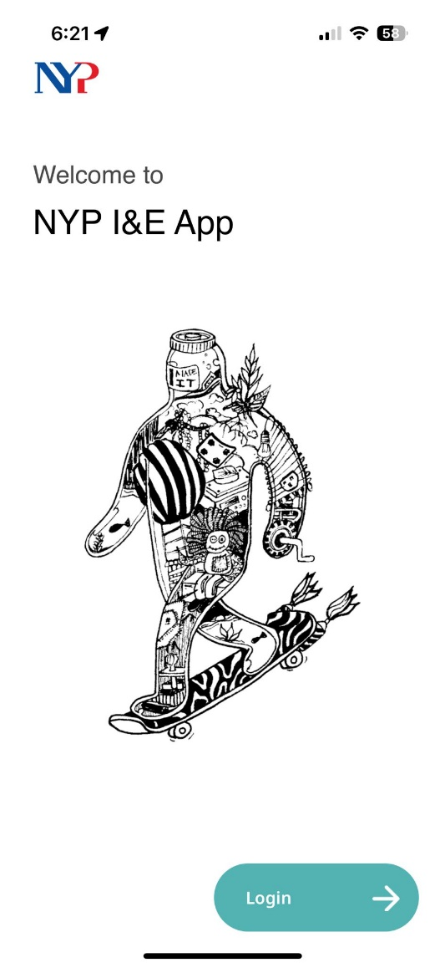
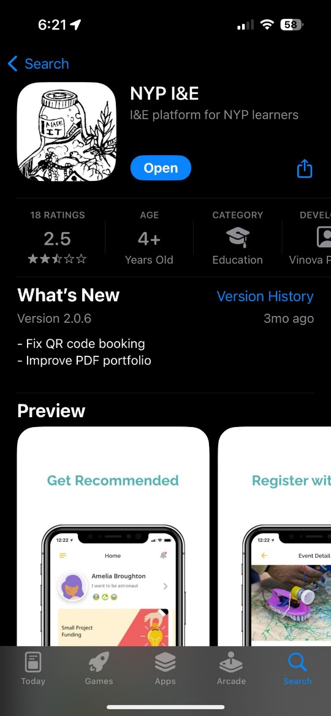
Download the NYP I&E application on your phone and log in using your NYP email.

Booking a time slot
To book a time slot for a 3D printer, these are the steps required:
- Press on “Scan” at the bottom of the application.
- Scan the QR code on the printer (skip step 3)
OR press “Manually Book”.
- Press “Spaces” at the top
- Pick any of the 3D Ultimakers 2+ printers that you wish to use.
- Select your preferred time slot.
- For the reason you want to book this space, select Final Year Project (FYP)
- Press Book to book your time slot for 3D printing.
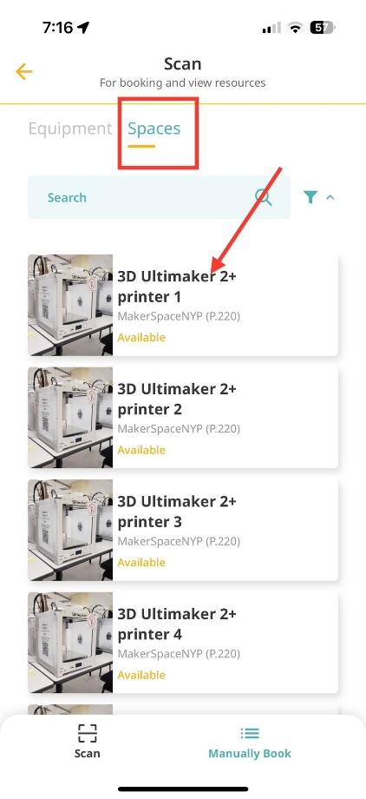
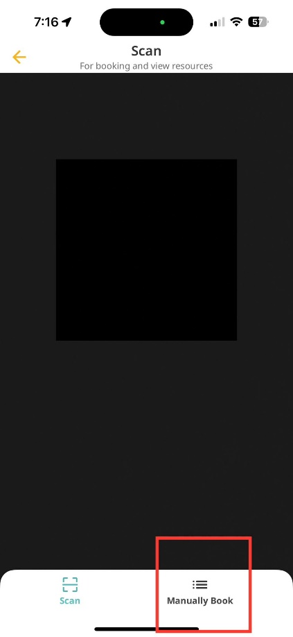
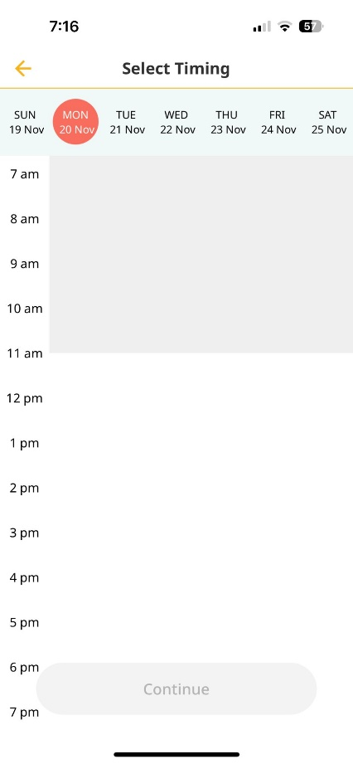
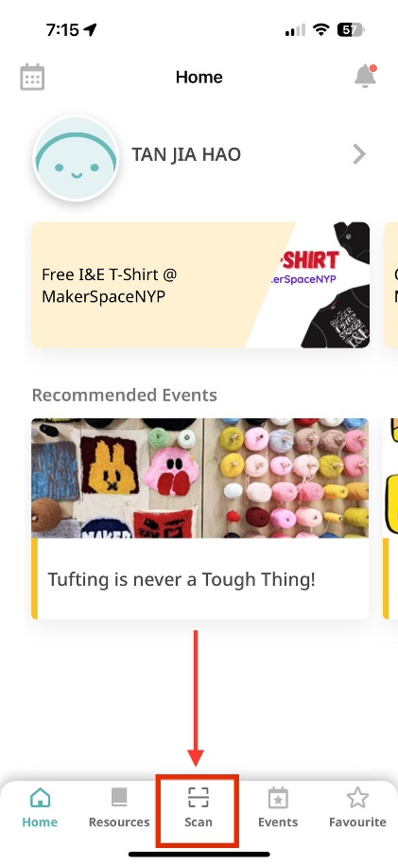
Do not forget to check in with your application once it reaches your time slot.

5.0 System Testing
This video demonstrates how the device works and it has been tested several times to ensure that it is accurate and works accordingly.
Double click on the mp4 files to access them.

Code & Codes Explaination
#define BLYNK_TEMPLATE_ID "TMPL6m9YGNb1p"
#define BLYNK_TEMPLATE_NAME "Testing"
#define BLYNK_AUTH_TOKEN "P9bNs6rV3ueE_1IyMcFENswClBBzs8x-"
#define BLYNK_PRINT Serial

#include <WiFi.h>
#include <WiFiClient.h>
#include <BlynkSimpleEsp32.h>
#include <Wire.h>
#include <Adafruit_MLX90614.h>

char ssid[] = "Jiahao";
char pass[] = "cardes123";

#define FLAME_SENSOR_1_PIN 39
#define FLAME_SENSOR_2_PIN 36
#define MOTION_SENSOR_PIN 26
#define GAS_SENSOR_PIN 34
#define BUZZER_PIN 13 // Define your buzzer pin number
#define GAS_THRESHOLD 3500 // Set your gas threshold value
#define TEMPERATURE_THRESHOLD 35.0 // Set your temperature threshold value

Adafruit_MLX90614 mlx = Adafruit_MLX90614();
BlynkTimer timer;

void setup() {
Serial.begin(115200);
pinMode(FLAME_SENSOR_1_PIN, INPUT);
pinMode(FLAME_SENSOR_2_PIN, INPUT);
pinMode(MOTION_SENSOR_PIN, INPUT);
pinMode(BUZZER_PIN, OUTPUT); // Initialize buzzer pin as output

mlx.begin(); // Initialize the MLX90614 sensor
Blynk.begin(BLYNK_AUTH_TOKEN, ssid, pass);
timer.setInterval(1000L, sendSensorData);
}

void loop() {
Blynk.run();
timer.run();
}

void sendSensorData() {
int flame1 = digitalRead(FLAME_SENSOR_1_PIN);
int flame2 = digitalRead(FLAME_SENSOR_2_PIN);
int motion = digitalRead(MOTION_SENSOR_PIN);
int gasValue = analogRead(GAS_SENSOR_PIN);

flame1 = !flame1;
flame2 = !flame2;

float temperature = mlx.readObjectTempC(); // Read object temperature in Celsius

// Send data to Blynk
Blynk.virtualWrite(V7, flame1); // Virtual Pin V1 for Flame Sensor 1
Blynk.virtualWrite(V8, flame2); // Virtual Pin V2 for Flame Sensor 2
Blynk.virtualWrite(V2, motion); // Virtual Pin V3 for Motion Sensor
Blynk.virtualWrite(V5, gasValue); // Virtual Pin V4 for Gas Sensor
Blynk.virtualWrite(V6, temperature); // Virtual Pin V6 for Temperature Sensor

// Check if gas level exceeds the threshold and activate the buzzer
if (gasValue > GAS_THRESHOLD) {
// Gas level exceeded the threshold, turn on the buzzer
digitalWrite(BUZZER_PIN, HIGH);
} else if (temperature > TEMPERATURE_THRESHOLD || flame1 == 1 || flame2 == 1) {
// Temperature above 35 degrees or flame detected, turn on the buzzer
digitalWrite(BUZZER_PIN, HIGH);
} else {
// Gas level is below the threshold and no flame or temperature issue, turn off the buzzer
digitalWrite(BUZZER_PIN, LOW);
}

// You can add more logic here to trigger additional actions based on sensor readings
}

#define BLYNK_TEMPLATE_ID "TMPL6m9YGNb1p"
#define BLYNK_TEMPLATE_NAME "Testing"
#define BLYNK_AUTH_TOKEN "P9bNs6rV3ueE_1IyMcFENswClBBzs8x-"
#define BLYNK_PRINT Serial
- BLYNK_TEMPLATE_ID: Template ID for the Blynk project.
- BLYNK_TEMPLATE_NAME: Template name for the Blynk project.
- BLYNK_AUTH_TOKEN: Authorization token for Blynk.
- BLYNK_PRINT: Serial output for Blynk.
- #include <WiFi.h>
- #include <WiFiClient.h>
- #include <BlynkSimpleEsp32.h>
- #include <Wire.h>
- #include <Adafruit_MLX90614.h>

- Include necessary libraries for WiFi, Blynk, Wire (for I2C communication), and the MLX90614 temperature sensor.
- char ssid[] = "Jiahao";
- char pass[] = "cardes123";

- Define WiFi credentials.
#define FLAME_SENSOR_1_PIN 39
#define FLAME_SENSOR_2_PIN 36
#define MOTION_SENSOR_PIN 26
#define GAS_SENSOR_PIN 34
#define BUZZER_PIN 13 // Define your buzzer pin number
#define GAS_THRESHOLD 3500 // Set your gas threshold value
#define TEMPERATURE_THRESHOLD 35.0 // Set your temperature threshold value
- Define pin assignments and threshold values for flame sensors, motion sensor, gas sensor, buzzer, and thresholds.
Adafruit_MLX90614 mlx = Adafruit_MLX90614();
BlynkTimer timer;
- Create instances of the MLX90614 temperature sensor and the Blynk timer.
void setup() {
Serial.begin(115200);
pinMode(FLAME_SENSOR_1_PIN, INPUT);
pinMode(FLAME_SENSOR_2_PIN, INPUT);
pinMode(MOTION_SENSOR_PIN, INPUT);
pinMode(BUZZER_PIN, OUTPUT); // Initialize buzzer pin as output

mlx.begin(); // Initialize the MLX90614 sensor
Blynk.begin(BLYNK_AUTH_TOKEN, ssid, pass);
timer.setInterval(1000L, sendSensorData);
}
- Setup function: Initialize serial communication, set pin modes, initialize sensors, connect to Blynk, and set the data send interval.

void loop() {
Blynk.run();
timer.run();
}
- Loop function: Run Blynk and the timer.
void sendSensorData() {
int flame1 = digitalRead(FLAME_SENSOR_1_PIN);
int flame2 = digitalRead(FLAME_SENSOR_2_PIN);
int motion = digitalRead(MOTION_SENSOR_PIN);
int gasValue = analogRead(GAS_SENSOR_PIN);

flame1 = !flame1;
flame2 = !flame2;

float temperature = mlx.readObjectTempC(); // Read object temperature in Celsius
- Function to read sensor data: Read digital and analog values from flame, motion, and gas sensors, and read temperature from the MLX90614.
// Send data to Blynk
Blynk.virtualWrite(V7, flame1); // Virtual Pin V1 for Flame Sensor 1
Blynk.virtualWrite(V8, flame2); // Virtual Pin V2 for Flame Sensor 2
Blynk.virtualWrite(V2, motion); // Virtual Pin V3 for Motion Sensor
Blynk.virtualWrite(V5, gasValue); // Virtual Pin V4 for Gas Sensor
Blynk.virtualWrite(V6, temperature); // Virtual Pin V6 for Temperature Sensor
- Send sensor data to Blynk using virtual pins.
// Check if gas level exceeds the threshold and activate the buzzer
if (gasValue > GAS_THRESHOLD) {
// Gas level exceeded the threshold, turn on the buzzer
digitalWrite(BUZZER_PIN, HIGH);
} else if (temperature > TEMPERATURE_THRESHOLD || flame1 == 1 || flame2 == 1) {
// Temperature above 35 degrees or flame detected, turn on the buzzer
digitalWrite(BUZZER_PIN, HIGH);
} else {
// Gas level is below the threshold and no flame or temperature issue, turn off the buzzer
digitalWrite(BUZZER_PIN, LOW);
}
- Check conditions and activate the buzzer based on gas level, temperature, and flame sensor readings.

